Traffic Volume Prediction and Congestion Classification
[Name]
[Date]

Abstract
Traffic congestion in urban areas is a significant issue in cities, slowing down productivity, damaging the environment, and escalating the stress of commuters. The conventional fixed-time traffic lights and simple sensor-based systems fail to respond to the changing traffic status, and thus an intelligent predictive system is required in this project. The LSTM model predicts the number of vehicles per hour at four junctions using a 24-hour look-back window on the Kaggle Traffic Prediction dataset which had 48,120 hourly records at four junctions.
SVM, Rand Forest and KNN are used to classify the levels of congestion as Low, Moderate and High. Findings indicate that the LSTM has RMSE 17.37 and MAE 13.87, whereas SVM has the highest results on classification with 62% accuracy and 0.57 macro F1-score. It is possible to make adaptive signal timing with predicted traffic patterns, which prove the rule-based decision logic, and illustrate the possibility of deploying deep learning, machine learning, and decision-support methods to manage urban traffic systems intelligently in cities.

Table of Contents
Abstract II
1 Introduction 1
1.1 Objectives 2
2 System Design Architecture 3
3 Related Work 3
4 Technical Background 5
5 Method 6
6 Implementation 7
6.1 Data Loading and Initial Exploration 7
6.2 Outlier Handling 8
6.3 Feature Engineering and Exploratory Data Analysis (EDA) 9
6.4 Data Preparation for Modeling 11
6.5 Model Implementation 12
7 Testing and Results 13
7.1 Regression Model Performance (LSTM) 13
7.2 Classification Model Performance (RF, SVM, KNN) 13
7.3 Model Comparison and Analysis 14
8 Expected Timeline & Milestones 15
9 Conclusion 16
10 References 18

List of Figures
Figure 1: Architecture diagram of the system, 4
Figure 2: Dataset preview, 8
Figure 3: Dataset Summary, 9
Figure 4: Boxplot showing vehicle counts before and after IQR capping, 10
Figure 5: Line plot of daily traffic trend, 10
Figure 6: Line plot: hourly traffic profile, 11
Figure 7: Bar plot: day-of-week traffic distribution, 11
Figure 8: Line plot of monthly traffic variation, 12
Figure 9: Table showing LSTM input sequences and corresponding targets, 12
Figure 10: code snippet of model implementation, 13
Figure 11: Actual vs predicted of traffic of LSTM, 14
Figure 12: Accuracy, Macro F1-score, Precision, Recall per model, 14
Figure 13: Confusion matrices for each classification model, 15
Figure 14: Feature importance plot from Random Forest, 15
Figure 15: Table comparing all models with key metrics (regression and classification), 16
Figure 16: Bar chart comparing all models with key metrics (regression and classification), 16

Introduction
The problem of traffic jams in the city is severe in the contemporary city that directly impacts time, fuel consumption, air quality, and overall quality of life of commuters. The metropolitan regions have been urbanised leading to high degree of vehicular density that has led to excessive congestion, unreliable travelling time and polluting the environment through motor vehicle emission. Not only are they economically expensive but also socially because individuals are stressed and unproductive during long trips. The planners and transport authorities are always trying to find the means of cutting into the traffic jam and improving the traffic movement within the context of the continuously complex transportation systems (Nadrian et al., 2022).
The old types of the traffic lights primarily operate the fixed time based controls and the actual changes in the traffic are disregarded. Although these systems can respond to the normal traffic patterns when the traffic is not at its peak, they usually cannot respond to the dynamic situation, such as, accidents, peak traffic, or seasonal variations. The inefficiency of common signal timing thus compounds delay and fuel usage and emissions resulting in high fuel consumption and emissions. The weakness of the traditional traffic management systems emphasizes the necessity to possess data-based smarter techniques that are capable of responding to the varying state of traffic (Koch et al., 2023).
The project will attempt to develop a data-based system in an effort to make predictions on the prevailing levels of traffic volume and congestion to enable adaptive signal timing strategies. The system will rely on past traffic information in forecasting the patterns of congestion by trying to forecast the traffic flow models and type of divisions of the degree of congestion in such a way that an urban traffic control agency can develop more flexible signal control systems. The following are the main objectives of the work, (i) to study the right predictive models to predict the level of traffic, (ii) to compare the effectiveness of the classification methods to estimate the level of congestion and (iii) to assess the performance of the different machine learning models to decide on the best performance.
Considering the scope of this paper, the analysis will be restricted to offline analysis using historic traffic statistics. At the time it is not within its scope to roll out or to interface with existing traffic infrastructure. The Kaggle Traffic Prediction Dataset which has approximately 48,120 data points of four intersections in the city in an hour has been used in the project. The records consist of vehicle counts, times and junction names that may be utilized as an entire base to educate and design features and assess the models.
The report is presented in the following manner. Section 3 contains the work related which comprises the traditional methods of statistics, machine learning methods and articles on traffic prediction. The discussion of time-series properties, machine learning algorithms, and the majority of preprocessing and assessment metrics is presented in Section 4 of the document where the technical background is provided. Part 5 and 6, respectively, contain the description of the methodology and implementation, including the description of the data processing and model development, and the exploration. Section 7 covers results of testing, analysis and model comparisons and Section 8 gives the thought closing research by providing insights, achievement and limitations (Miftah et al., 2025).

Objectives
The main objective of the project is to create a hybrid machine learning architecture of the traffic volume prediction and congestion classification that can theoretically be applied to adaptive traffic signal control.
The following are specific objectives:
- Training of a time-series forecasting model with LSTM on hourly arrival and departure of vehicles to achieve a root mean squared error (RMSE) of at least 15 percent of the mean vehicle traffic on the test dataset.
- Create classification models to estimate the congestion level (Low, Moderate, High) with the help of the Random Forest, SVM, and KNN classifiers and strive to achieve high macro-averaged results on the classes.
- Determine and explain the strongest features that support the trends of traffic volume and congestion through feature importance analysis.
- Develop a clear system architecture that illustrates how the amount of traffic and congestion predicted can be used to make the adaptive decisions on the timing of the traffic signals.
- Issues of document keys in preprocessing, modeling and deployment of data, and mitigation measures.
These goals will help the project show how predictive analytics may be used to enhance intelligent traffic management systems within the smart city settings.

System Design Architecture
The system proposed is intended as a complete predictive traffic analytics system that converts an historical traffic into decision support information that can be used to manage congestion and address adaptive traffic signal control. The architecture is based on a pipeline that is modular with three stages, which include data acquisition and preprocessing then feature engineering, predictive modelling, evaluation, and output generation (Gheorghe & Soica, 2025). The historic traffic data that includes the count of vehicles passing by the various urban junctions on an hourly basis are first transformed to ensure that the data maintains a temporal order, which is fundamental in the analysis of time-series. Preprocessing involves outlier management based on Interquartile Range method, time information extraction based on timestamps, one-hot identifiers encoding based on junction identifiers and feature scaling to provide model stability. The processed data is in turn introduced into two predictive elements which are complementary. Forecasting of traffic volumes is done with the help of Long Short-Term Memory neural network with 24 hours look-back to capture sequence of traffic and daily variations. Parallel to this, supervised machine learning models such as the random forest, the Support Vector Machine, and the K-Nearest Neighbours are used to classify congestion by using quantile based threshold congestion levels. The metrics used in the evaluation of model performance include the use of the appropriate regression and classification measures. As a concept, both forecasting and classification module output can be combined in a rule-based decision layer to help in adaptive signal timing strategies. Even though the present implementation is offline, the modular architecture is scalable and allows real-time implementation in the future (Magar et al., 2024).
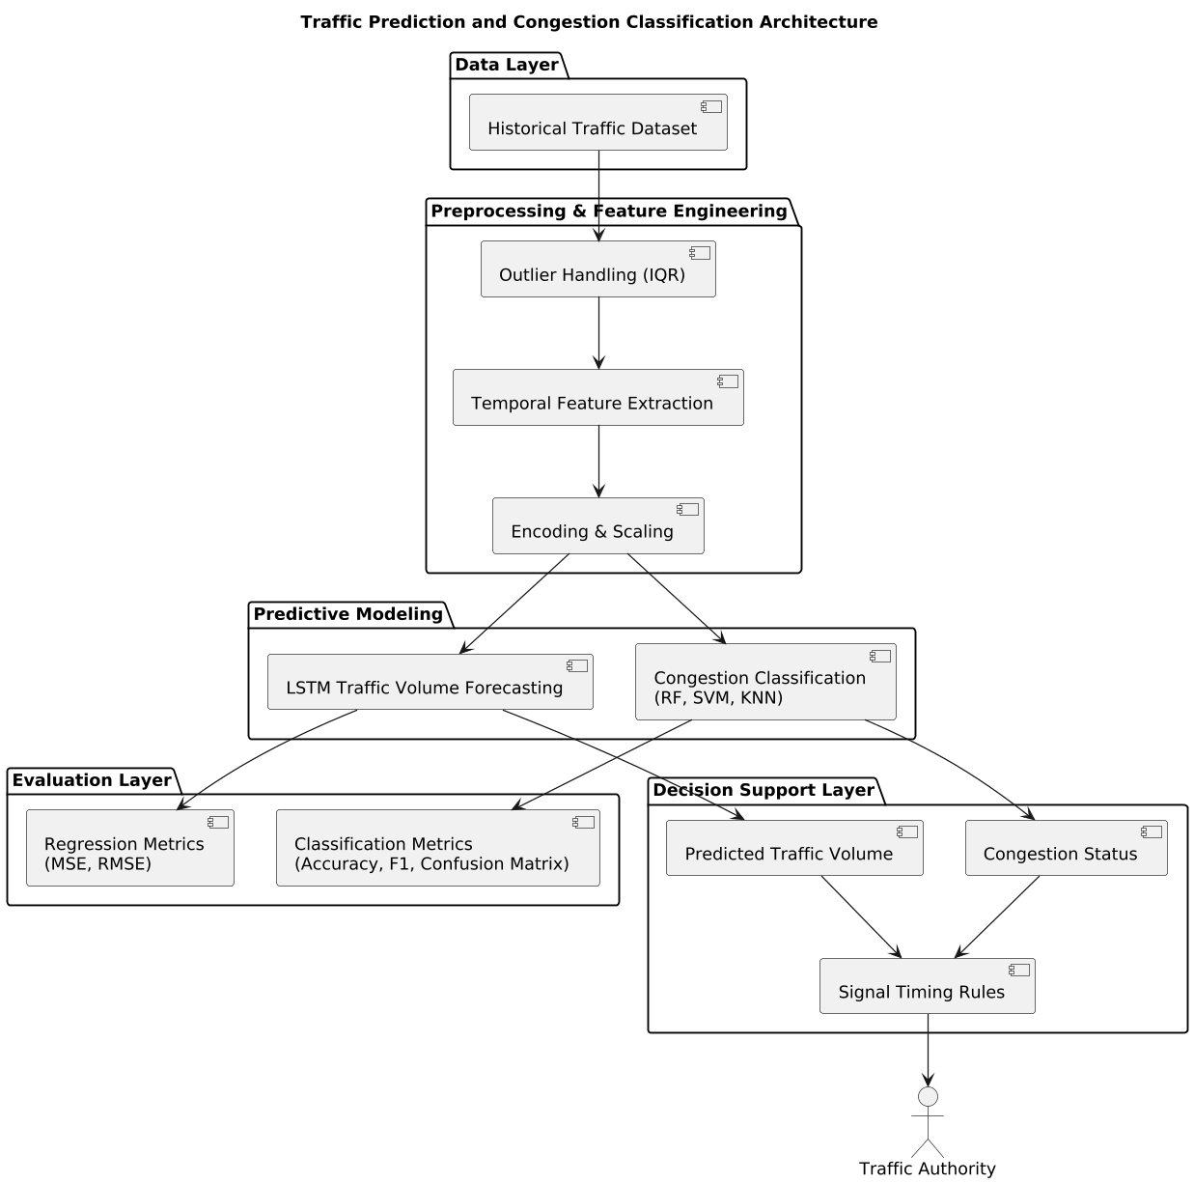
Figure 1: Architecture diagram of the system,
(Source: author)

Related Work
Traffic predicting is a widely studied issue in the sphere of urban transportation and approaches to the field have evolved throughout the years starting with the traditional statistical techniques to the contemporary ones based on machine learning techniques. Most of the classical methods rely on time-series analysis, and one of the most famous methods is the Auto-Regressive Integrated Moving Average (ARIMA). ARIMA is suitable in linear trends, short term forecasting and that of time-dependent trends in traffic flow data. Non-linear dynamics, sudden fluctuations and external forces affecting the traffic, however, are not always considered by them leading to their limitation in application in complex city situations (Mystakidis et al., 2025).
Due to the introduction of machine learning, more advanced plans of traffic prediction have become achievable. The supervised learning algorithms have addressed issues of predicting volumes of traffic, congestion grade, and anomalies. Random Forest Ensemble procedures consist of a set of decision trees that are employed in order to improve the predictive strength and the significance of features. The benefit of Support VectorMachines (SVM) is that, they can deal with non-linear boundaries in the classification of traffic problems compared to instance based algorithms like the K-Nearest Neighbors (KNN) which are beneficial in the fact that they make intuitive predictions by proximity. Linear Regression is a control model that is widely applied in prediction of traffic at a specific time.
Time-series forecasting has particularly been beneficial with deep learning techniques. The RNNs, along with their variants, the Long Short-Term Memory (LSTM) and the Gated Recurrent Unit (GRU) can better learn the time-specific aspects and long-term dynamics of the traffic flow data. Specifically, the LSTMs are effective in terms of the ability to recall the past sequences and model the daily, weekly and seasonal variations. Other machine learning algorithms such as hybrid LSTM have been found to perform better in prediction and classification of congestion (Yuan et al., 2022).
The latest literature highlights the manner in which these approaches are implemented. In the paper, Khan and Thakur (2024) provided the comparative study of different models of the problem of urban traffic forecasting in the context of the role played by the LSTM and the ensemble classifier in exposing the peak congestion patterns. Others papers are on feature engineering, outlier treatment and adaptive quantile classification of congestion levels. The PeMS dataset, METR-LA and Kaggle Traffic Prediction Data are some of the well-known datasets that have been utilized in the studies and involves massive past information about the traffic at various crosses.
Nevertheless, in spite of the fact the improvement has been achieved to a great extent, the gaps remain numerous. The majority of the research only establish the predictive accuracy but not the interpretability, congestion quantile classification and applicability. Little attention has been done on multi-model comparisons being performed within a single framework, outlier mitigation strategies, and non-uniform distributions of data. The given project addresses these gaps through the application of the combination of forecasting and classification techniques, outlier detection and quantile based classes of congestion, and the discussed applicability of the predictive models to the real-life scenario of the traffic in the city (Antons et al., 2023).

Technical Background
The form of the traffic data is time-series, which is marked by the repetitions on a weekly, monthly and daily level. The size of cars in the intersection of the urban areas can be established by the fact that there are set highs and lows during the morning and evening times, low activity during weekends and season variations depending on holidays or special occasions. Such time-varying dependencies are needed so as to make appropriate predictions and categorize congestion.
Long Short-Term Memory (LSTM) network is a specialised type of a recurrent neural network that is highly suitable in the field of time-series traffic prediction. As opposed to the use of single RNNs, LSTM units employ memory cells and gating units that allow the network to memorize long-term dependencies and mitigate the process of vanishing gradients that regular RNNs are known to be associated with. It enables the LSTM models to acquire complex forms over time like periodic traffic surges and discontinuous changes. Recent history of traffic can be used by the model in sequence preparation e.g. a 24-hour look-back window to know the values of future values (Balawi & Tenekeci, 2024).
A set of machine learning algorithm are applied in order to categorize congestion. Random Forest This decision forest is an enhancement on predictive accuracy through the combination of multiple weak learners and quantification of the importance of the features. The Support Vector Machine (SVM) is also capable of crossing non-linear boundaries easily and can therefore be applied to categorize the levels of congestion even in the case where the patterns are irregular. K-Nearest Neighbors (KNN) is an example based algorithm which determines the label of the classes on the basis of similarity with the previous traffic instances. Linear Regression provides a reference point that is to be used in the comparison of advanced models against a base that is the continuous predictive of traffic volume.
Data must be preprocessed to ensure there is performance of the model. The outlier detection and capping method based on the Interquartile Range (IQR) is useful in preventing the chance of operation of biased predictions due to the extreme figures of vehicles. The feature engineering contribution is adding additional features to the input of the model, which are both temporal, such as hour, day of week and month, and nominal (e.g. junction identifiers), which are converted into one-hot features. Data normalisation through scaling normalises ranges of inputs and converts the neural networks (Leon et al., 2023).
The criteria of measurements are determined according to the type of its task. Mean squared error (MSE) and root mean squared error (RMSE) are applied to determine the difference between the actual and predicted volumes of traffic to use regression. Accuracy, macro-averaged precision, recall, F1-score and confusion matrices can be used in the classification to provide an overall view of performance of a model in the congestion conditions. All these technical aspects create a solid foundation on the predictive model building, adoption and assessment of the project.

Method
The project is grounded on the structured line that is dedicated to forecasting the traffic volumes and classifying the degree of traffic congestion according to the previous statistics. The workflow begins with data loading and early exploration, is then proceeded by preprocessing, feature engineering, model training and evaluation. The missing data, outlier detection, and scaling are preprocessed which implies that the quality of the inputs that will be in the regression and classification models will be of high quality. In feature engineering, temporal variables, such as hour of the day, day of the week and month, are represented and categorical variables, such as junction identifiers, are one-hot encoded (Mystakidis et al., 2025).
The method of data splitting involves an 80 / 20 train-test strategy in which 80 percent of the data is trained on and 20 percent is tested or evaluated. In the prediction of LSTM, sequence preparation consists of 24 hour look-back window where the model can find temporal relationship between the past traffic pattern. The number of vehicles is the targets of the regression model and the levels of the congestion of the classification model are the levels that are set by the ranks of the quantile. Using the function that is referred to as pd.qcut, the congestion classes are identified as Low, Moderate, and High and it provides a moderate approach to the evaluation of the classification performance.
A combination of regression and classification models is applied in the project in order to explore different perspectives of traffic forecasting. The LSTM models are trained to learn the time dynamics in the form of the traffic volumes but the random forest algorithm, the SVM and the KNN algorithms recognize the congestion level. Linear Regression is employed as a benchmark, which is applied to make predictions continuously. The choice of the model is concerned with simplicity in order to get the model on a baseline with the hyperparameters being maintained at default values so as to allow the assessment of the performance before any possible optimization (Muraina, 2022).
Blood pressure and blood glucose level data will be used to train machine learning models (scikit-learn), LSTM (tensorflow/keras) models will be created, and Python will be used to run Google Colab and data processing will involve using pandas and numpy libraries. Matplotlib and seaborn facilitate visualisation and analysis of discovery, which enables one to be aware of the trends of time and model predictions (Shi et al., 2023). This methodological scheme ensures the reproducibility of the research, provides the possibility of the multi-model comparison, as well as presents the clear foundation to the subsequent stages of the project implementation, testing, analysis, etc.

Implementation

Data Loading and Initial Exploration
The imported dataset using the aid of the pandas is Kaggle Traffic Prediction Dataset of approximately 48,120 hourly readings of four junctions. The simple descriptive statistics, the data types checks and the missing values checks provide us with a summary picture of the data quality and the type of structure. Initial steps indicate the trends of normal traffic with acute ones in the morning hours and evening hours and low figures in the middle of the night.
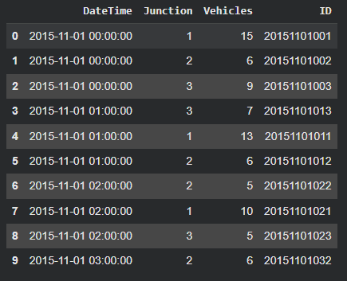
Figure 2: Dataset preview,
(Source: author)
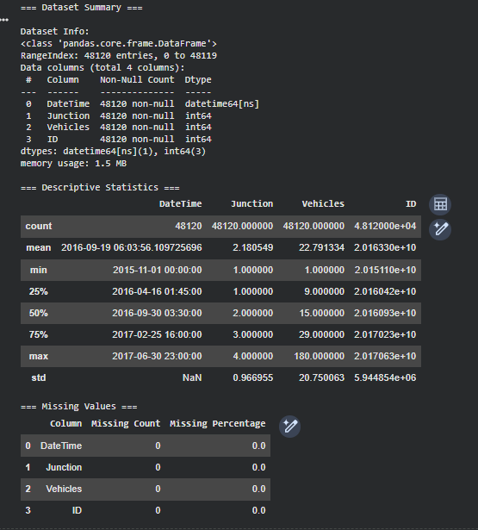
Figure 3: Dataset Summary,
(Source: author)

Outlier Handling
The Interquartile Range (IQR) approach is utilized with the aim of addressing the outliers of number of vehicles. The values will be upper and lower capped and extreme values will not have a disproportionate impact on the model performance. This ensures that patterns of realistic traffic are considered as opposed to some of the strange and rare cases in the models.
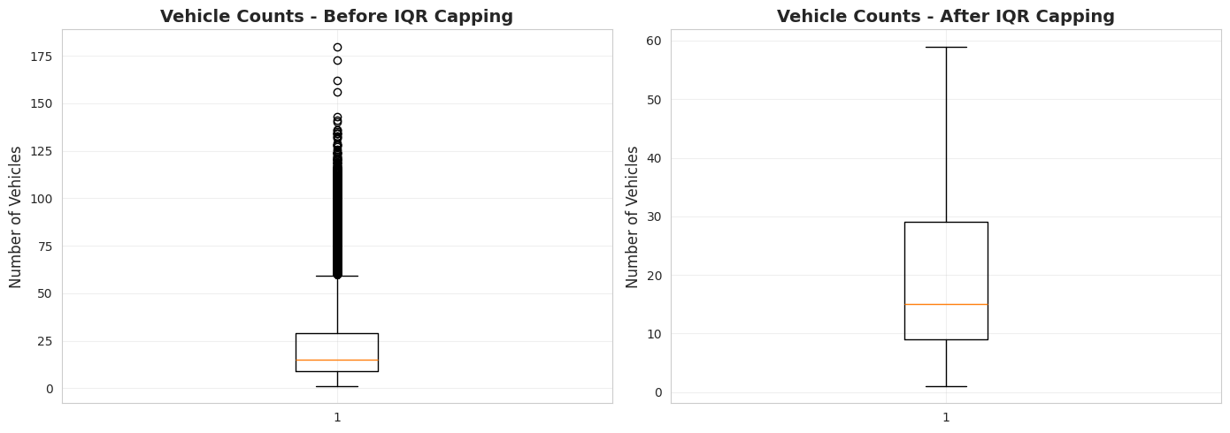
Figure 4: Boxplot showing vehicle counts before and after IQR capping,
(Source: author)

Feature Engineering and Exploratory Data Analysis (EDA)
The timestamps are transformed into temporal characteristics like hour of the day, day of the week, and month. Categorical features (junction identifiers) are one-hot coded and then used in machine learning. The EDA visualisation uncovers the trend of traffic behaviours.
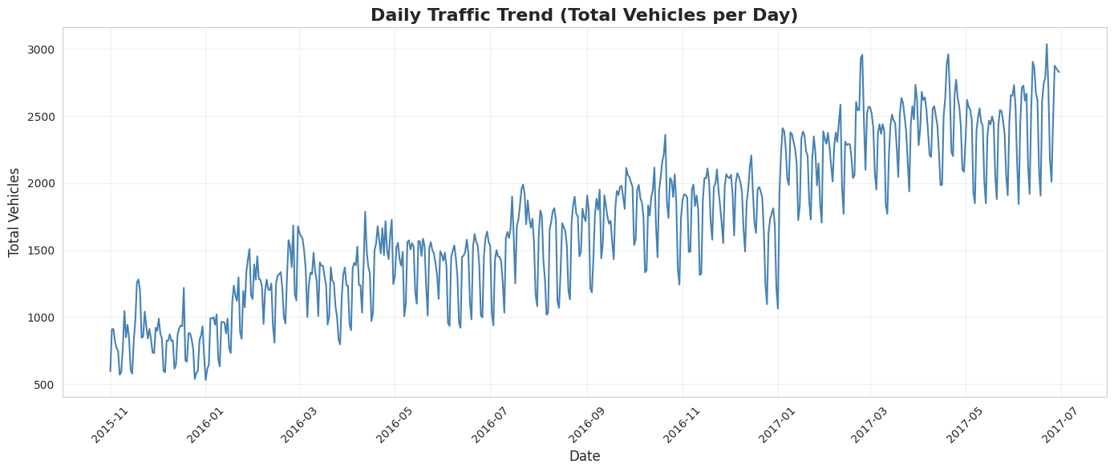
Figure 5: Line plot of daily traffic trend,
(Source: author)

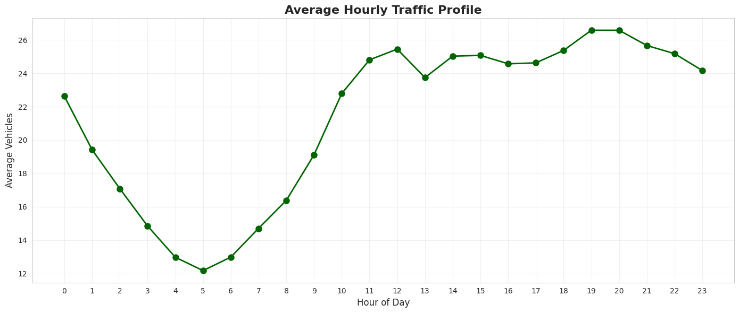
Figure 6: Line plot: hourly traffic profile,
(Source: author)
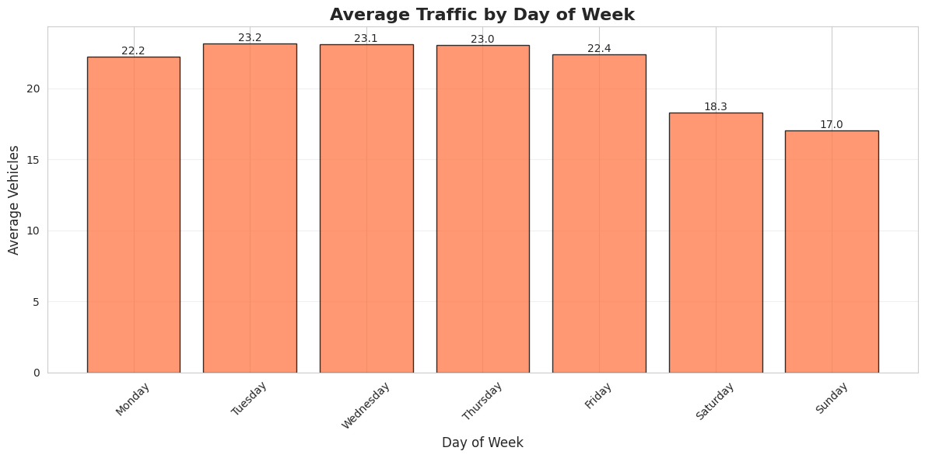
Figure 7: Bar plot: day-of-week traffic distribution,
(Source: author)
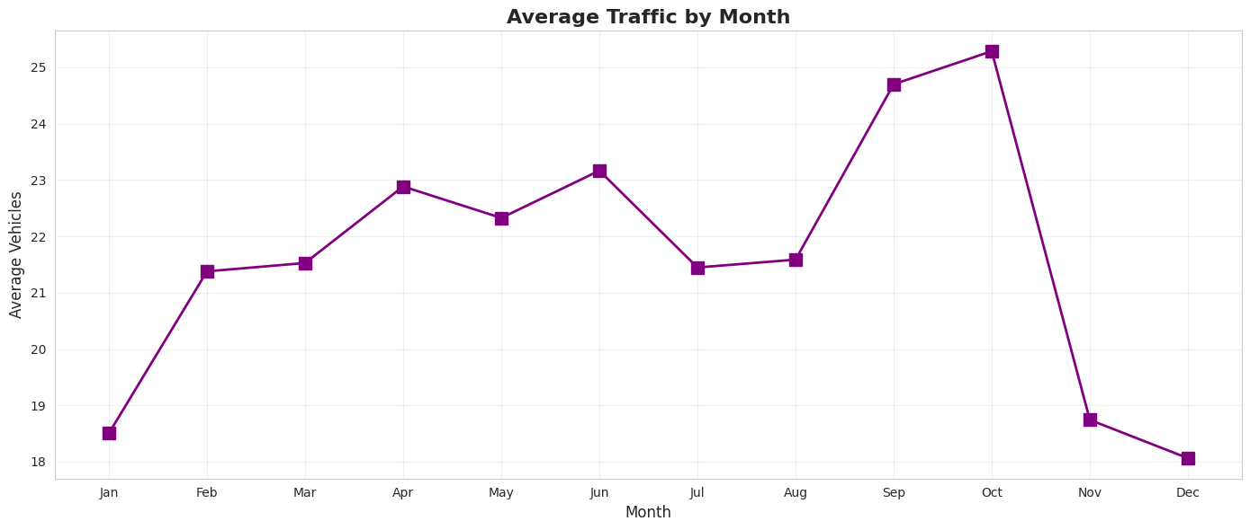
Figure 8: Line plot of monthly traffic variation,
(Source: author)

Data Preparation for Modeling
The need to standardise the numerical features scales the features to increase convergence in the LSTM network and other architectures that are sensitive to the ranges of the inputs. Considering the LSTM forecasting, the generated sequence will be of the 24-hours look back to determine the dependence of time. The number of vehicles is considered the regression targets and the number of vehicles is considered the classification targets basing on the quantile-based congestion levels (Low, Moderate, High) with the help of pd.qcut.
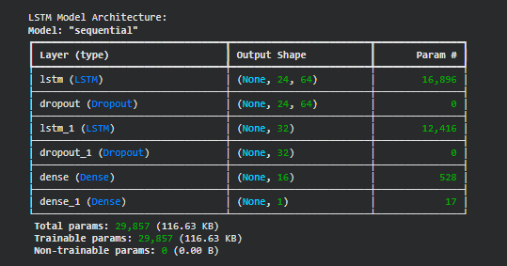
Figure 9: Table showing LSTM input sequences and corresponding targets,
(Source: author)

Model Implementation
The LSTM network consists of the input layer, hidderen layer and the output layer and ReLU and mean squared error loss. The training, which is done with the 80 percent training set, and validation, which is done with the 20 percent data, are used to train and validate the model respectively. Random Forest, SVM, and KNN are trained in terms of the classification of the congestion, whereas Linear Regression is applied as the baseline of the continuous prediction. Regular comparison of the baseline is ensured with a default level of hyperparameters.
The repository of data model comprises separate preprocessing, feature engineering, model training, evaluation and visualisation scripts and, therefore, it can be reproducible.
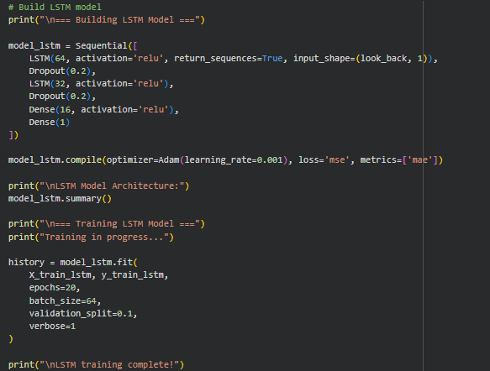
Figure 10: code snippet of model implementation,
(Source: author)

Testing and Results

Regression Model Performance (LSTM)
The predictive ability of the LSTM model is promising and is effective in capturing the time dynamics and peak of the traffic per day. The Root Mean Squared Error (RMSE) and the mean squared error (MSE) is an indicator of predictive and real deviations between the anticipated and actual traffic numbers.
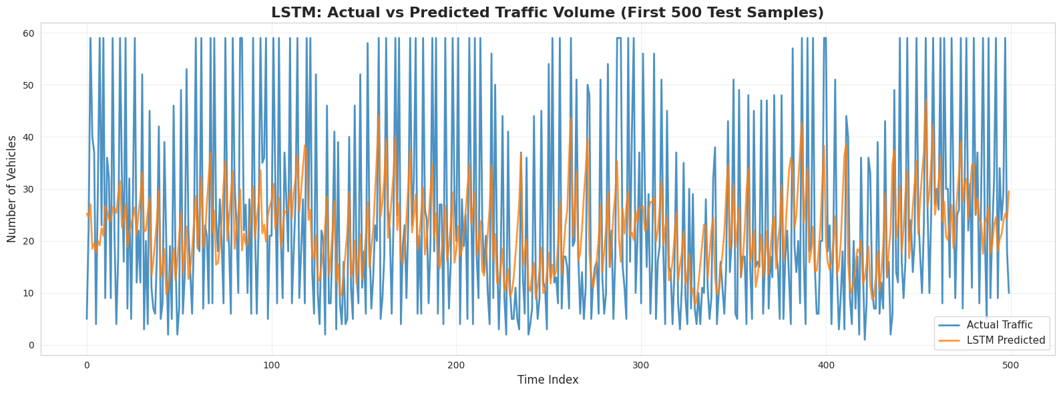
Figure 11: Actual vs predicted of traffic of LSTM,
(Source: author)

Classification Model Performance (RF, SVM, KNN)
The random Forest, SVM, and KNN models are used to test congestion classification. The macro-averaged F1-score, precision, and recall give an idea of the performance in Low, Moderate and High classes of congestion. The confusion matrices indicate some strong and weak aspects, particularly, the possibility to differentiate the levels of congestion that are close to each other. As a baseline, there is the use of Linear Regression.

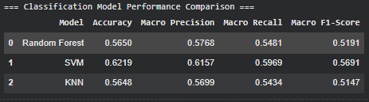
Figure 12: Accuracy, Macro F1-score, Precision, Recall per model,
(Source: author)
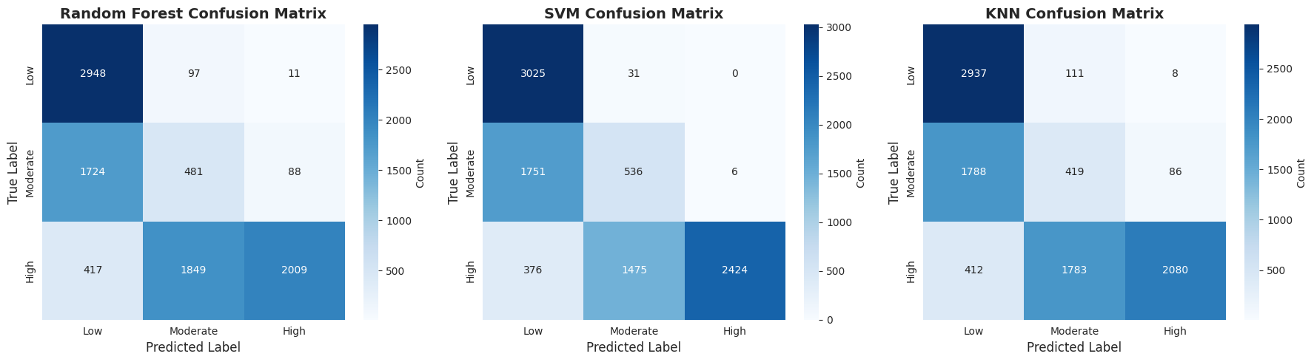
Figure 13: Confusion matrices for each classification model,
(Source: author)
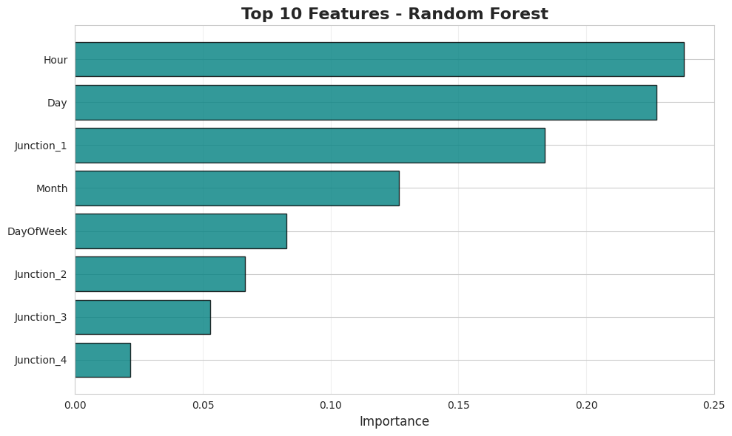
Figure 14: Feature importance plot from Random Forest,
(Source: author)

Model Comparison and Analysis
Models LSTM can be compared effectively with respect to regression work, but only the most suitable classification accuracy can be obtained by the Random Forest. KNN is mediocre in its output, and it is prone to imbalances in classes and SVM has drawbacks in non-linear separation within particular ranges. Its benefits include correct prediction of peak, reasonable congestion and resistance outlier classification. Its limitations include moderate misclassification, absence of external features and analysis offline.
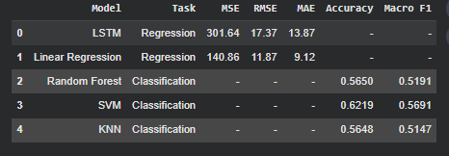
Figure 15: Table comparing all models with key metrics (regression and classification),
(Source: author)
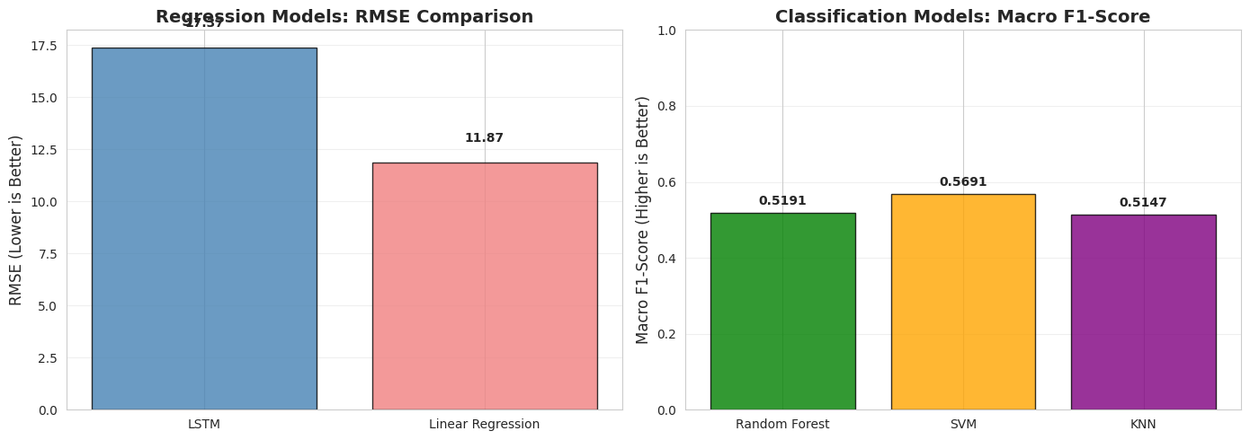
Figure 16: Bar chart comparing all models with key metrics (regression and classification),
(Source: author)

Addressing Challenges & Solutions
The creation of predictive models of urban traffic has several practical problems that are related to the quality of the data, complexity of the model and practical implementation. The poor data quality, such as the outliers of the abnormal cases or the malfunction of the sensors, can affect the model training unevenly, and the lack of the contextual factors, such as the weather, accidents, or the social activities, limits the predictive performance (Ulvi et al., 2024). The interquartile ranges (IQR) were used to address the issues of outliers and the temporal feature engineering was used to address the issues of daily, weekly and monthly traffic patterns, but further contextual information would improve the performance. The nonlinear, periodic and time-dependent traffic flow were the model issues, which were achieved by using LSTM model and 24 hours look-back window. The levels that were not represented in the dataset were coded using quantile based classification to give the same number of representations to the classes levels and the measure of macro-averages was coded to give overlaps between the high and moderate levels of congestion. Deep learning was enhanced by random Forest feature importance analysis to enhance its interpretability. Lightweight inference pipelines, periodic retraining, API-based services and rule-based decision layer overcame deployment challenges such as the issue of real-time data latency, scalability, concept drift issues, and integration with current traffic signal systems to offer real-time, reliable and data responsive traffic control (Majeed et al., 2025).

Expected Timeline & Milestones
Phase | Activities | Deliverables / Outcomes | Notes / Future Extensions
Phase 1: Problem Definition & Dataset Selection | - Define project scope (predicting traffic and classifying congestion at urban crossroads)  - Conduct initial literature review on traffic forecasting, ML-based congestion detection, and intelligent traffic signal systems  - Select suitable dataset (Kaggle Traffic Prediction Dataset) | - Defined project objectives and scope  - Dataset ready for analysis | - Time-series resolution and junction coverage selected to support model development
Phase 2: Exploratory Data Analysis & Preprocessing | - Check data quality (missing values, duplicates, anomalies)  - Feature engineering (derive temporal features from timestamps)  - Outlier detection and control using interquartile range  - Develop baseline regression and classification models | - Cleaned and preprocessed dataset  - Baseline performance benchmarks established | - Inform model selection and further feature engineering
Phase 3: Model Integration & System Documentation | - Implement and assess LSTM forecasting model  - Implement and assess classification models using time-aware validation  - Establish system architecture for traffic signal timing decision support  - Evaluate issues in data processing, model development, and deployment | - Integrated predictive system  - Comprehensive project report | - Documentation of challenges and suggested resolutions
Future Milestones / Extensions | - Incorporate real-time traffic data streams  - Integrate external variables (e.g., weather, events)  - Optimize hyperparameters to improve predictive accuracy  - Simulate adaptive traffic signal control strategy  - Prototype small-scale testing for smart city implementation | - Enhanced predictive system  - Closer to real-world deployment in smart city traffic management | - Enables future scaling and practical implementation

Conclusion
The project succeeds in the sense that it applies numerous machine learning techniques to project the volumes of traffic and classify the degree of congestion in urban constructions. Through implementing the techniques of LSTM networks in the area of time series forecasting, and ensemble and instance-based classifiers in the domain of congestion classification, the paper gives an indication on whether it is feasible to speed up the process of traffic management using the techniques of data-driven approaches. The LSTM model is quite competent in the depiction of the temporal changes, the prediction of the daily and the weekly changes in the traffic effectively, but the Random Forest provides a good classification outcome, which is a reliable way of evaluating the quantile based congestion.
The derived insights are important in demonstrating that time based events particularly the hour and the day of the week are significant predictors of the traffic behaviour and therefore the necessity to implement quality feature engineering. The outlier detection and capping strategy combined is the assurance that the drastic values will not impact the model predictions and hence the entire is stronger. Comparative studies have revealed that the less complex versions of the models, such as Linear Regression and KNN do provide some valuable reference points, however there are more complex models that may be significant in the per cent of accuracy and reliability of the prediction in the classification of the congestion.
The challenges of trying to foresee the traffic in the cities are also present in the project. Limitations include the absence of real time data integration, external factors (i.e. weather or special events) are not taken into account and the classes in the congestion categories are not well balanced. The hyperparameter tuning has not been conducted over a large scale and that could have restricted the optimality of the performance of the models. In addition, offline analysis is limited in the research and in the real world, there would be need to integrate with real time traffic surveillance and adaptive signal control infrastructure.

References
Antons, D., Breidbach, C. F., Joshi, A. M., & Salge, T. O. (2023). Computational literature reviews: Method, algorithms, and roadmap. Organizational Research Methods, 26(1), 107-138.
Balawi, M., & Tenekeci, G. (2024). Time series traffic collision analysis of London hotspots: Patterns, predictions and prevention strategies. Heliyon, 10(4).
Koch, L., Brinkmann, T., Wegener, M., Badalian, K., & Andert, J. (2023). Adaptive traffic light control with deep reinforcement learning: An evaluation of traffic flow and energy consumption. IEEE transactions on intelligent transportation systems, 24(12), 15066-15076.
Leon, J. P. A., de la Cruz Llopis, L. J., & Rico-Novella, F. J. (2023). A machine learning based distributed congestion control protocol for multi-hop wireless networks. Computer Networks, 231, 109813.
Miftah, M., Desrianti, D. I., Septiani, N., Fauzi, A. Y., & Williams, C. (2025). Big data analytics for smart cities: Optimizing urban traffic management using real-time data processing. Journal of computer science and technology application, 2(1), 14-23.
Muraina, I. (2022, February). Ideal dataset splitting ratios in machine learning algorithms: general concerns for data scientists and data analysts. In 7th international Mardin Artuklu scientific research conference (pp. 496-504).
Mystakidis, A., Koukaras, P., & Tjortjis, C. (2025). Advances in traffic congestion prediction: an overview of emerging techniques and methods. Smart Cities, 8(1), 25.
Mystakidis, A., Koukaras, P., & Tjortjis, C. (2025). Advances in traffic congestion prediction: an overview of emerging techniques and methods. Smart Cities, 8(1), 25.
Nadrian, H., Heizomi, H., Shirzadi, S., Moradi, M. S., & Hajibadali, P. (2022). Exploring the dimensions of urban quality of life associated with urban traffic jam: The development and validation of an instrument. Journal of Transport & Health, 26, 101463.
Shi, B., Dhaliwal, S. S., Soo, M., Chan, C., Wong, J., Lam, N. W., ... & Ang, S. B. (2023). Assessing Elevated Blood Glucose Levels Through Blood Glucose Evaluation and Monitoring Using Machine Learning and Wearable Photoplethysmography Sensors: Algorithm Development and Validation. JMIR AI, 2(1), e48340.
Yuan, T., da Rocha Neto, W., Rothenberg, C. E., Obraczka, K., Barakat, C., & Turletti, T. (2022). Machine learning for next‐generation intelligent transportation systems: A survey. Transactions on emerging telecommunications technologies, 33(4), e4427.
Gheorghe, C., & Soica, A. (2025). Revolutionizing Urban Mobility: A Systematic Review of AI, IoT, and Predictive Analytics in Adaptive Traffic Control Systems for Road Networks. Electronics (2079-9292), 14(4).
Magar, V., Ruikar, D., Bhoite, S., & Mente, R. (2024). Innovative inter quartile range-based outlier detection and removal technique for teaching staff performance feedback analysis. Journal of Engineering Education Transformations, 176-184.
Ulvi, H., Yerlikaya, M. A., & Yildiz, K. (2024). Urban traffic mobility optimization model: A novel mathematical approach for predictive urban traffic analysis. Applied Sciences, 14(13), 5873.
Majeed, M. A., Phichaisawat, S., Asghar, F., & Hussan, U. (2025). Data-Driven Optimized Load Forecasting: An LSTM Based RNN Approach for Smart Grids. IEEE Access.

